CAS PY 106

In-class Note 11

1. Power
2. P = I \* V or P = I^2 \* R or P = V^2/R
3. Light bulbs usually have the voltage of 120V
4. If power is 100W,

P = V^2/R

100 = 120^2/R

R = 120^2/100

R = 144 Ohms (volt/amp)

1. Resistors will cause a change in potential
2. Ohm’s law relates potential difference across a resistor to the resistance and current flowing through it
3. Resistors in Series
4. Two resistors A and B that are in series can be replaced by an equivalent resistor with resistance
5. 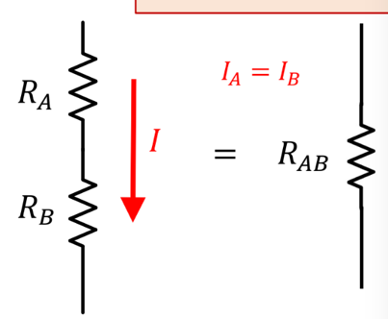
6. R = Ra + Rb (resistor is the same as adding two separate resistors if in series)
7. Ia = Ib (current is the same through two resistors in series)
8. V = Va + Vb (voltage is same as adding two voltages going through resistor A and B)
9. Resistors in Parallel
10. 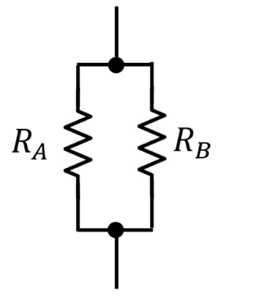
11. Two resistors A and B that are in parallel can be replaced by an equivalent resistor with resistance

1/R = 1/Ra + 1/Rb (resistor is same as adding inverse of two separate resistors if in parallel)

1. I = Ia + Ib (current is the same as adding two currents going through two resistors in parallel)
2. Va = Vb (voltage is same over both resistors)
3. Example: two resistors in series
4. 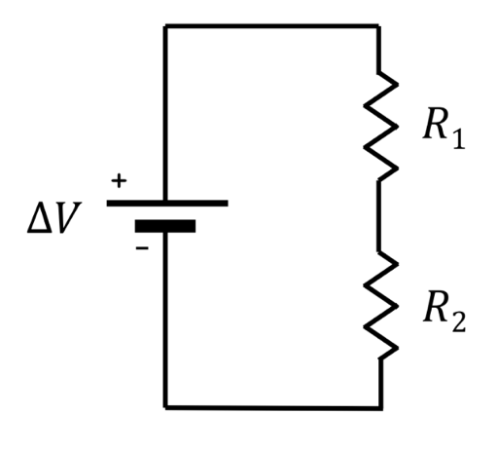
5. Two resistors with 4 Ohms and 2 Ohms connected to 12V battery
6. What is V1 and V2?

I = V/R = 12 / (4+2) = 2 amps

V1 = R1 \* I = 4 \* 2 = 8V

V2 = R2 \* I = 2 \* 2 = 4V

1. Rules for combinations of resistors
2. Here R is the equivalent resistance when we sum over all resistors in series or in parallel
3. 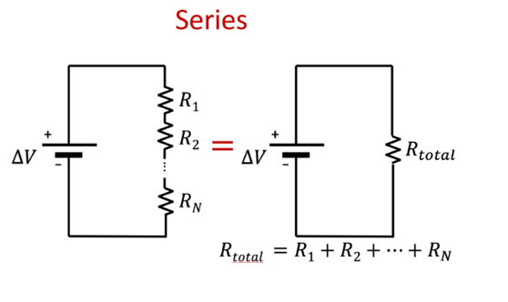
4. 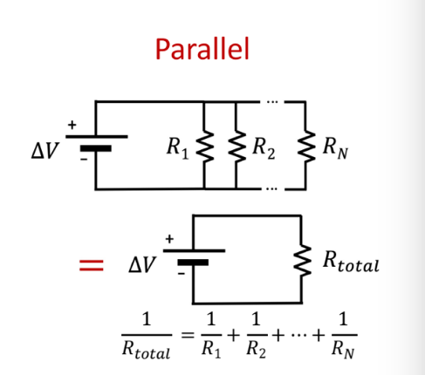
5. How bright does each bulb shine?
6. 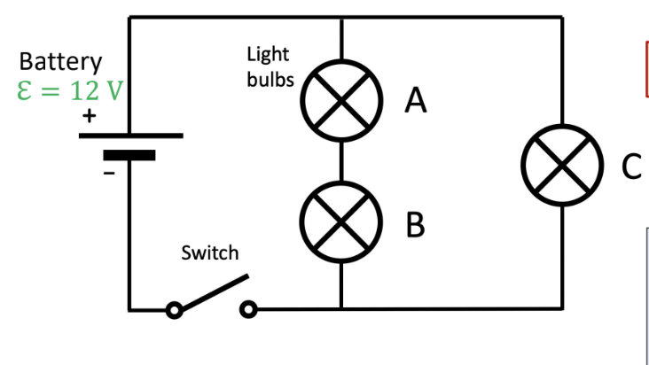
7. The bulbs shine brighter if they dissipate more power in the form of heat
8. You can solve these problems by determining equivalent resistance, the current, voltage drop, then determining power dissipated for each
9. C > A=B